A Project Report

On

Watch Dogs

Submitted in partial fulfillment of

the requirement of PROJECT-III

SUBJECT (BIT 206 CO)

of

Bachelors Of Information Technology

**Submitted to**



**Purbanchal University**

**Biratnagar, Nepal**

**Submitted By**

Bodhi Manandhar(331947)

Sambodhi Manandhar(331960)

Sandip Khadka(331961)

**KANTIPUR CITY COLLEGE**

Putalisadak, Kathmandu

December , 2023

A Project Report

on

Watch Dogs

Submitted in partial fulfillment of the requirement of PROJECT-III

SUBJECT (BIT 206 CO)

of

Bachelors Of Information Technology

**Submitted to**



**Purbanchal University**

**Biratnagar, Nepal**

**Submitted By**

Bodhi Manandhar(331947)

Sambodhi Manandhar(331960)

Sandip Khadka(331961)

**Project Supervisor**

Kiran Khanal

Senior Asst.Professor

**KANTIPUR CITY COLLEGE**

Putalisadak, Kathmandu

Table of Content

Abstract ii

Acknowledgement iii

Preface iv

Declaration v

Supervisor's Approval vi

Chapter 1:.Introduction 1

1.1Background 1

1.2 Problem Statement 1

1.3 Objectives 2

1.4 Scope and Limitation 2

1.5 Hardware Requirements 2

1.6 Hardware Specifications 3

1.7 Organization of Documentation 7

Chapter 2: Literature Overview 9

Chapter 3: System Design 10

3.1 Block Diagram 10

3.2 Circuit Diagram 13

3.3Algorithm 14

3.4 Flowchart 15

3.5 Tools and Techniques 16

3.6 Library and Functions 17

3.7 Testing and debugging 18

Chapter 4: Methodology and Scheduling 19

1.1 Schedule 19

4.2 Assignment and Roles 20

4.3 Gantt Chart 21

Works Cited and Reference 22

Appendix A : Pin Diagram and Images 23

Appendix B Datasheet 27

Conclusion 33

**List of Tables and Figures**

Figure 1: Block Diagram 10

Figure 2: Circuit Diagram 13

Figure 3: Flowchart 15

Figure 4: Gantt Chart 21

Table i: System Specification 16

Table ii: Library Files 17

Table iii: Functions Used 17

Table iv Test Cases 18

Table v: Roles and Responsibility 20

# Abstract

Any organization, institution and our home require security. Just the assurance that something is safe gives us the peace of mind. This project aims to improve residential security with minimal resources. An automated system such as this does not require a lot of capital and once installed it does not need to be bothered again. It will do its job continuously once the system is active. In security, the complexity is the enemy of effectiveness as such our project uses simple keybad and SMS-based apparatus to deliver quality based protection.

Project Watch Dogs uses Keypad as input, 8051microcontroller as processing unit and LCD and DC motor as output unit. The DC motor requires more current than the microcontroller can provide, so the project uses BJT(bc547) as a switvh for the external source and H-bridge(L298N) for reversing the polarity for the DC motor.

# Acknowledgement

We would like to thank the BIT and BCA department for the wonderful opportunity to showcase our skill and widen our knowledge. We would like to show gratitude towards Mr. Kiran Khanal sir for acting as our supervisor and giving us many wonderful points in regarding of making this project successful. Special thanks to Mr. Rabi Shrestha sir for his insight and guidance in the project. Also, we would like to show appreciation to Mr. Saroj Pandey, Hod of department of BIT and Computer Applications and Mr. Ashim KC sir to give us the opportunity to improve our skills in hardware related projects. We also would like to show our gratitude to Jon Subba for his support in the development of this project.

# Preface

Watch Dogs is a Security project and not a product but a process and we are trying to provide a simple and affordable piece of technology. Our inspiration is from other similar security options where they use sensors to provide security on a larger scale. We make use of 8051 microcontroller to make a compact system for protection. While researching we have found other projects with similar use of different components. We have decided to use a unique approach to further secure our way of life.

# Declaration

We declare that this project report titled Watch Dogs submitted in partial fulfillment of the BIT is a record of original work carried out by us under the supervision of Mr. Kiran Khanal and has not formed the basis for the award of any other degree or diploma, in this or any other Institution or University. In keeping with the ethical practice in reporting scientific information, due acknowledgements have been made wherever the findings of others have been cited.

Bodhi Manandhar (331947)

Sambodhi Manandhar (331960)

Sandip Khadka (331961)

Date:

# Supervisor's Approval

This is to certify that the major project entitled Watch Dogs undertaken and demonstrated by Bodhi Manandhar, Sambodhi Manandhar and Sandip Khadka has been successfully completed under my supervision as a partial fulfillment of the requirements for the degree of BIT, 3rd semester under Purbanchal University. I, henceforth, approve this project to be awarded the certificate by the concerned authority.

During supervision, I found students hardworking, skilled and ready to undertake any professional work related to this field in future.

-------------------------

Kiran Khanal

Project Supervisor

Senior Assistant Professor

Date:

# Chapter 1:.Introduction

This project involves the use of 8051 microcontroller to develop a constructive and effective system. The microcontroller is very versatile in its use as such many of our day-to-day activities can be automated through its use. An automated intrusion detection system is very practical as it does not need any monitoring and the system will work as it is programmed. The basics of the operation are to send message to the contact upon detecting any kind of activity.

## 1.1Background

We intend to use 8051 microcontroller and keypad for detecting intrusion and attempts to get in the environment which will then send the alert message to the owner through GSM module. It has a keypad which accepts a password and gives three attempts to enter a correct password. After correct password has been entered the door will open and after smetimes auto-lock will kick in the door will close again.

## 1.2 Problem Statement

A simple password is more efficient in keeping the security than a lock system. We can possess a unique set of passwords to grant access. In today`s time we look for better enhancement of the existing work. The operational work is not the only concern. We look for improvements in everything as such; the project deals with the concept of smart locks.

## 1.3 Objectives

The objectives of the project are as such

* To provide affordable security to its users
* To provide means of password entry
* To send alert message in case of intrusion

## 1.4 Scope and Limitation

Although it is an effective system it does have its limitation in terms of operational and technological threshold.

* It cannot handle images.
* It may experience interference and latency while sending message.
* The password once set cannot br changed.
* After the alert has benn sent, the system will still allow to enter the password..

## 1.5 Hardware Requirements

The hardware components that are required are as follow:

* 8051 family microcontroller and development kit
* Programmer
* Bipolar Junction Transistor(BJT)
* GSM module SIM800L
* 4x4 Keypad
* 16x2 LCD
* 10k potentiometer
* H-bridge L298N
* DC-DC buck converter
* DC motor

## 1.6 Hardware Specifications

**1) 8051 microcontroller**

* 4 KB on-chip ROM (Program memory).
* 128 bytes on-chip RAM (Data memory).
* The 8-bit data bus (bidirectional).
* 16-bit address bus (unidirectional).
* Two 16-bit timers.
* Instruction cycle of 1 microsecond with 12 MHz crystal.
* Four 8-bit input/output ports.
* 128 user-defined flags.
* Four register banks of 8 bit each.
* 16-byte bit-addressable RAM.
* The general purpose registers are 32 each is 8-bit.
* 8051 has two external and three internal interrupts.
* It has a 16-bit program counter and data pointer.

**2)** **SIM800L GSM/GPRS Module:**

* Supply Voltage: 3.8V – 4.2V
* Recommended Supply voltage: 4V
* Power Consumption:
  + sleep mode < 2.0mA
  + idle mode < 7.0mA
  + GSM transmission (avg): 350 mA
  + GSM transmission (peak): 2000mA
* Module Size: 25×23 mm
* Interface: UART (max. 2.8V) and AT commands
* SIM card socket: microSIM (bottom side)
* Supported frequencies: Quad Band (850/950/1800/1900 MHz)
* Antenna connector: IPX
* Status Signaling: LED
* Working temperature range: -40 to +85 C

**3) 16×2 Alphanumeric LCD:**

➢ Operating Voltage: 4.7V-5.3V

➢ 2 Rows with each rows producing 16 characters

➢ Power Consumption is 1mA with no back-light

➢ Character can be built with 5×8 pixel box

➢ Works in 4-bit and 8-bit mode

➢ Obtainable in blue and green back-light

**4) 10k Potentiometer:**

➢ Value: 10K

➢ Potential: 500Ohms – 1M Ohms(+-20%)

➢ Rotational life of Potentiometer: 10000 cycles

➢ Rotational life for Joystick: 100000 cycles min

➢ Rated Power: 1A at AC/DC 125V

➢ Rotational Travel: 300°

➢ Withstand Voltage: 1 minute at AC 500V

➢ Sliding noise: Less than 100 milli volts

**5) Bipolar Junction Transistor(BJT): bc547**

* **Type:** NPN (Negative-Positive-Negative) bipolar junction transistor.
* **Package Type:** TO-92 - This is a small plastic package with three leads (collector, base, and emitter) that is easy to handle and suitable for through-hole PCB mounting.
* **Collector Current (Ic):** The maximum current that can flow through the collector terminal is typically around 100 mA.
* **Collector-Base Voltage (Vcb):** The maximum voltage that can be applied across the collector and base terminals is typically around 80 volts.
* **Collector-Emitter Voltage (Vce):** The maximum voltage that can be applied across the collector and emitter terminals is typically around 45 volts.
* **Base Current (Ib):** The maximum current that can be supplied to the base terminal is typically around 5 mA.
* **Power Dissipation (Pd):** The maximum power dissipation is typically around 500 mW.
* **Transition Frequency (ft):** The transition frequency is the frequency at which the current gain (hfe) drops to 1. The typical value for ft in BC547 is around 100 MHz.
* **hfe (Current Gain):** The current gain (hfe) of the BC547 transistor typically ranges from 110 to 800.
* **Operating Temperature Range:** The BC547 is designed to operate within a specified temperature range. It is typically around -65°C to +150°C.

**6) H-bridge(L298N)**

* **Supply Voltage (Vss):** The L298N typically operates within a voltage range, often around 4.5V to 46V. This range allows it to be compatible with various power sources.
* **Maximum Continuous Current per Channel (Ic):** Each H-bridge in the L298N can handle a maximum continuous current, usually around 2A.
* This means that each motor connected to the L298N should not draw more than this specified current.
* **Peak Current per Channel (Ipeak):** The L298N can handle higher peak currents for short durations. The peak current is typically higher than the continuous current, often around 3A.
* **Logic Voltage (Vss):** The L298N uses a separate voltage for its logic inputs, and this is typically in the range of 4.5V to 7V. This allows it to interface with microcontrollers or other digital control systems.
* **Logic Current (Ib):** The current required for the logic inputs is usually in the range of tens of mA.
* **Built-in Freewheeling Diodes:** The L298N has built-in diodes to provide a path for the back-emf generated by the motors, protecting the circuit from voltage spikes.
* **Thermal Shutdown:** The IC has a thermal shutdown feature that protects it from overheating by disabling the outputs when the temperature exceeds a certain threshold.
* **Cross-Conduction Protection:** The L298N includes protection against cross-conduction, helping to prevent shoot-through currents in the H-bridge.
* **Operating Temperature Range:** The typical operating temperature range for the L298N is around 0°C to 130°C.

**7) 4x4 Keypad**

* **Operating Voltage:** Typically operates at low voltages, commonly around 3V to 5V.
* **Operating Current:** The current consumption depends on the design and the specific requirements of the keypad, but it is usually in the range of a few milliamperes.
* **Contact Resistance:** The contact resistance between the conductive traces is an important factor for reliable operation. It is usually in the range of ohms.
* **Life Cycle:** Membrane keypads have a specified number of operations before they may start to show signs of wear. This is often in the range of tens of thousands to millions of cycles.
* **Operating Temperature:** The keypad should be able to operate within a specified temperature range. Common ranges are from -20°C to 70°C or wider, depending on the application.

**Note: For Hardware data-sheet, refer to the relevant appendix(data-sheet source:manufacture**

**website)**

## 1.7 Organization of Documentation

**Chapter 1:** It contains the general detail and introduction of the project. It contains the main objective of the project with features of the project. It also contains the scope and limitation of the project. It contains the brief idea of the components and hardware used in the project.

**Chapter 2:** It contains overview of the similar projects that used similar components.We studied how those components were used in those projects and implemented the part in our project.

**Chapter 3:** It contains algorithm and flowchart depiting the workflow of the system. It also has circuit diagram, block diagram and use of functions and library files and some of the test cases.

**Chapter 4:** It contains schedule, roles and assignments and Gantt Chart to show the stages of the system of the project

**Conclusion**: It contains the overall summary of the whole project and the overall assembly of the project.

# Chapter 2: Literature Overview

**Project 1: Password Based Home Security System**

This project is an example of simple embedded system. It is a combination of specific hardware and software for specific function. It has an expected number of inputs which gives a certain output. The data is given to the microcontroller is given through the keypad and the output is shown through LCD display. The previous project consisted of a simple lock system without alert or cooldown.

**Project 2: MIRA“Micro-controller Integration by Radio Frequency in Automation System”**

Micro-controller Integration by Radio Frequency in Automation System uses DTMF( DualMulti-frequency) for controlling the appliances attached to the output of 8051/52. For e.g. we are far away from our home and we need to turn our Air Cooler ON, unless we are home at that moment we can’t turn on anything, but due to the system we can just send a simple DTMF tone by calling it and turn that very device on or off from any location from our phone.

# Chapter 3: System Design

The need of the components is heavily based on the usage of the system. The system must operate on its own after installation. It must provide the desired result in a specific timeframe. Considering the scalability, the system has been kept in mind of use in a small frame. Since its application is considered to be in a single room or entrance the design in very straightforward.

## 3.1 Block Diagram

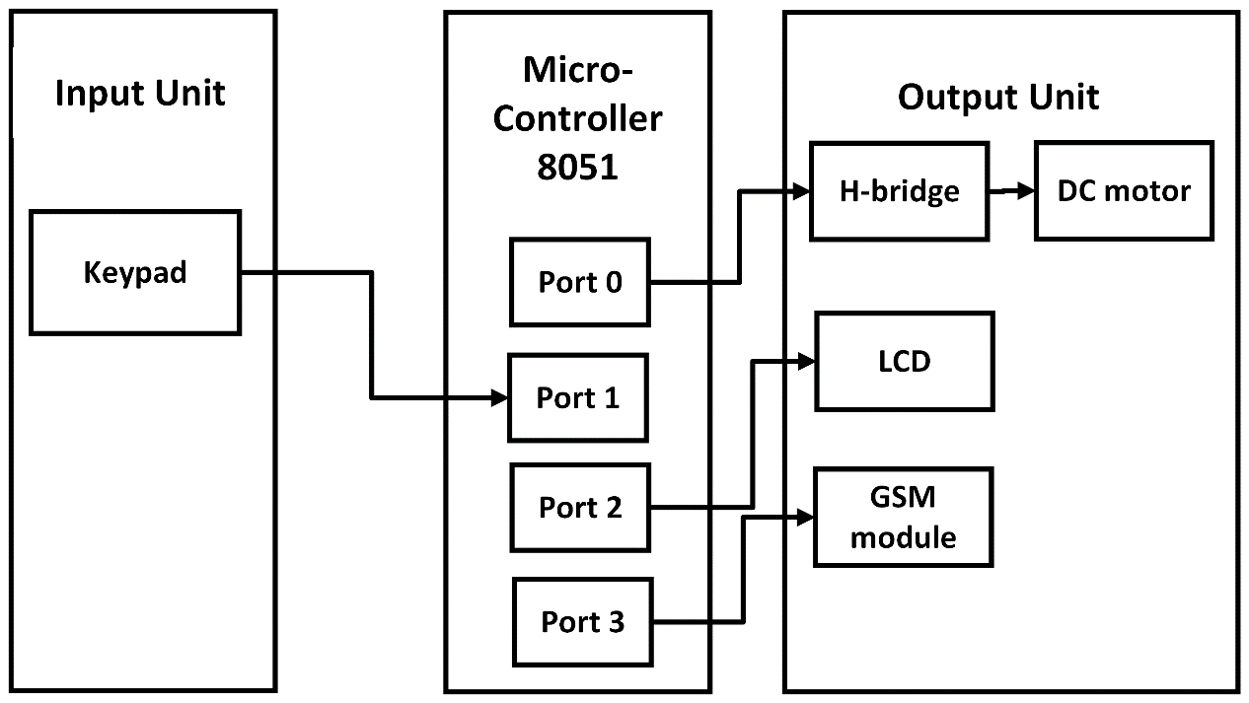

Figure 1: Block Diagram

INPUT UNIT

It is the unit with which the user interacts and provides input to the system. It is responsible for providing some information to the microcontroller that is processed. The input unit has two parts:

1. Keypad Unit- It is a 3x4 keypad which is used to input pass-code for the system. The ‘#’ symbol is used as enter key and the pass-code is limited to numeric keys and ‘*’.

MICROCONTROLLER

8051 is the main processing unit of the system and will be used connect all the input and output unit. It is an 8-bit microcontroller. It is built with 40 pins, 4kb of ROM storage and 128 bytes of RAM storage, two 16-bit timers. It consists of are four parallel 8-bit ports, which are programmable as well as addressable as per the requirement. An on-chip crystal oscillator is integrated in the microcontroller having crystal frequency of 12 MHz.

OUTPUT UNIT

The output unit is used to show the result of the interaction with the user. The output unit has three parts:

1. DC motor- It is used to operate the lock mechanics of the system. It will open the mechanics if the pass-code is correct, after which it waits for some time and will automatically close the lock.
2. L298N- It is a dual H-Bridge motor driver which allows speed and dirction control of DC motors. It is used for driving DC and stepper motors. When the power supply is less than or equal to 12V, then the internal circuitry will be powered by the voltage regulator and the 5V pin can be used as an output pin.
3. DC-DC Buck Converter- It is a step down converter which decreases the voltage, while increasing current from its input supply to its output. They acts against the input voltage. They are essentially intermediary between systems of different voltage levels throughout the system.
4. SIM 800L- It is used to send an alert message to the user to notify them that the pass-code has been entered wrong 3 times. Low cost and quad band frequency makes this module perfect for projecs. Communication is established through serial communication and instruction is given through microcontroller.
5. LCD- It is used to show the result of the interaction and is to display the system status.

## 3.2 Circuit Diagram

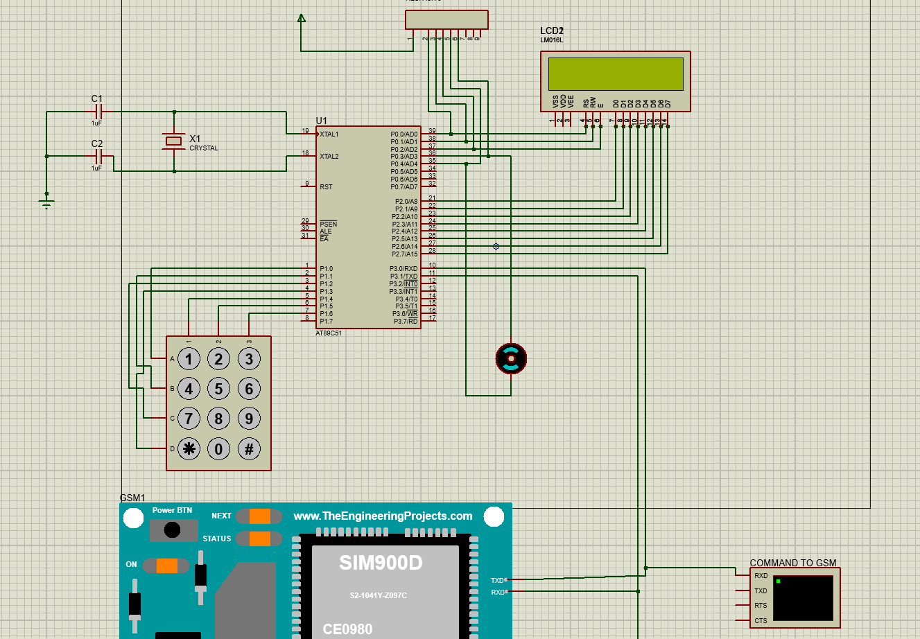

Figure 2: Circuit Diagram

## 3.3Algorithm

Step 1: START

Step 2: Initialize the LCD and display “ENTER PASSWORD”.

Step 3: Enter password.

Step 4: Was the password correct?

If YES unlock the door through DC motor and display "Password Matched".

If NO display “WRONG PASSWORD”

Step 5: Check the number of wrong entries.

If wrong entry <3 send SMS and put cooldown of 10 seconds.

Else GOTO 2

Step 6: STOP

## 3.4 Flowchart

Figure 3: Flowchart

## 3.5 Tools and Techniques

The project was done in:

* Software development tool: Keil 5
* Circuit Simulation Software: Proteus 8

Table i: System Specification

|  |  |
| --- | --- |
| OS Name | Microsoft Windows 10 |
| System manufacturer | Lenovo |
| Processor | Intel [i5-4200CPU@ 1.60GHz,2301](mailto:i5-4200CPU@1.60GHz,2301)Mhz |
| RAM | 4 GB |
| System type | X64-based PC |

## 3.6 Library and Functions

Table ii: Library Files

|  |  |
| --- | --- |
| Header File | Description |
| #include<reg51.h> | All the special functions registers address mapped to predefined variable names. |
| #include<sim800l.h> | Custom created header file with several required functions for serial communication to SIM800l module. |

Table iii: Functions Used

|  |  |
| --- | --- |
| Functions | Description |
| void delay(unsigned int time) | To create a delay |
| void lcd_cmd(unsigned char dat) | To input command to LCD |
| void lcd_data(unsigned char dat) | To input data to LCD |
| void lcddis(unsigned char *s,unsigned char r) | To display string in LCD |
| void init() | To initialize the LCD |
| void send_sms() | AT commands to send SMS |
| void lockback() | To lockback the door after opening |
| void check() | To check if the password is correct |
| void sim_delay() | To delay SIM for initializing |

## 3.7 Testing and debugging

Along the development of this project we incountered several errors and bugs in both simulations and hardware assembly and integration of components. Here below we have listed a few of them.

Table iv Test Cases

|  |  |  |  |  |
| --- | --- | --- | --- | --- |
| S.N. | Test Case | Expected Outcome | Actual  Outcome | Remarks |
| 1 | Integration of keypad with its algorithm | Appearing of '*' character after taking input | Not appearing of '*' character | Fail |
| 2 | Store input in pwd variable and display status | Display of '*' character and status | Display password matched or wrong with '*' | Pass |
| 3 | Change of data pins in LCD | Display all the information correctly | Display all the information correctly | Pass |
| 4 | Use of sim 900D as in simulation | Send alert SMS correctly | Problem in sending SMS | Fail |
| 5 | Use of sim 800l | Send alert SMS correctly | SMS properly sent | Pass |

# Chapter 4: Methodology and Scheduling

This project is a combination of keypad, dc motor, LCD, IR and GSM module. The IR sensor detects the person and activates the system if it detects someone. After detection LCD is activated and asks for password. If the password is correct the DC motor activates if password is wrong more than 3 times it sends an SMS to the owner.

## Schedule

**Week 1:** Concept Submission

 Gather a simple idea for the project with expected plan for the project.

**Week 2:** Research and Analysis

Identify the hardware requirements and sensors.

Research available components

Create a project plan.

**Week 2:** System Design

Design and develop the basic simulation in Proteus.

Test and debug the code for simulation.

**Week 2-9:** Coding and Assembly

Check simulation for errors.

Assemble hardware components.

**Week 6-12:** Debugging and Testing

Test the program for semantic and syntax error.

Test the system for errors.

**Week 2-12:** Documentation

Basic documentation will begin from the beginning.

Progress will be added simultaneously according to the level of completion.

## 4.2 Assignment and Roles

Table v: Roles and Responsibility

|  |  |
| --- | --- |
| Member Name | Roles and Responsibility |
| Bodhi Manandhar | GSM module, DC buck converter / Chapter 1,3, Reference, Conclusion |
| Sambodhi Manandhar | Keypad, BJT, H-bridge / Chapter 3,4, Appendix A and B |
| Sandip Khadka | DC motor and LCD / Chapter 2 |

## 4.3 Gantt Chart

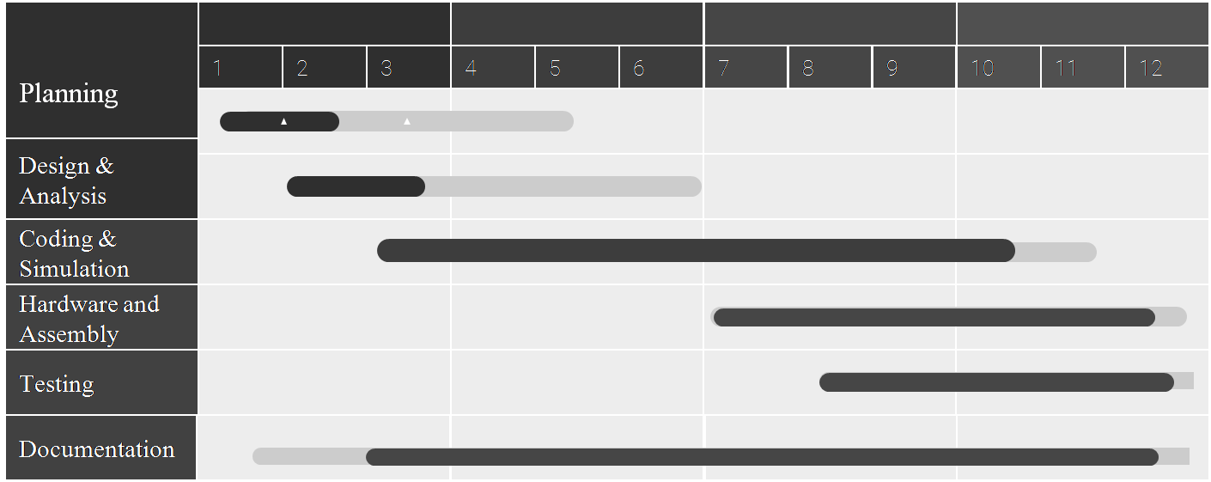

Figure 4: Gantt Chart

# Works Cited and Reference

**Mazidi, Muhammad Ali.** *The 8051 Microcontroller and Embedded.*

**2023.** *EmbeTronicx.* [Online] 2023.

*EmbeTronixc.*[Online][Cited:10/02/2023.] https://embetronicx.com/tutorials/microcontrollers/8051/ir-sensor-interfacing-with-8051/.

*Electronicshub.* [Online] [Cited: 10 10, 2023.] https://www.electronicshub.org/gsm-interfacing-8051-microcontroller/.

*Youtube*[Online][Cited:10/11/2023.] https://www.youtube.com/watch?v=Xp7MugnxLMs.

**2023.***The Engineering Projects.* [Online]10/11/2023. https://www.theengineeringprojects.com/2021/05/infrared-tracker-sensor-library-for-proteus.html.

https://lastminuteengineers.com/sim800l-gsm-module-arduino-tutorial/

# Appendix A : Pin Diagram and Images

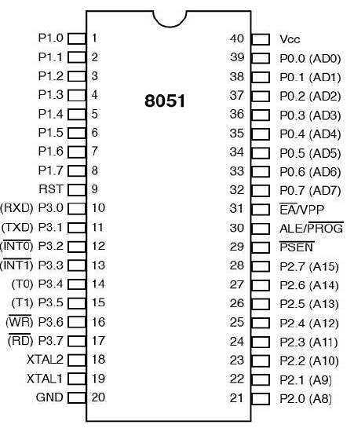

Pin Diagram of 8051

<https://www.tutorialspoint.com/microprocessor/microcontrollers_8051_pin_description.htm>

Pin diagram of SIM 800L

Functional Diagram

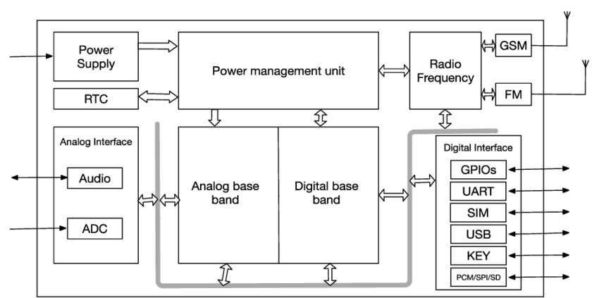

4x4 Keypad

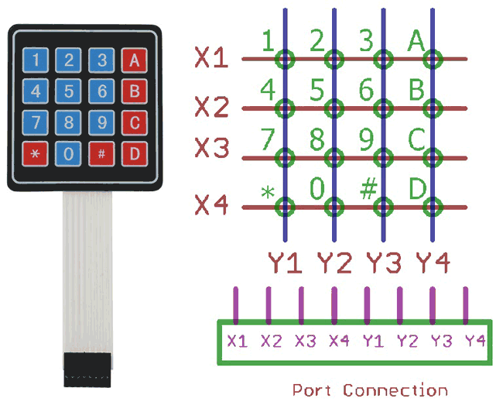

LCD Block Diagram

10k potentiometer diagram

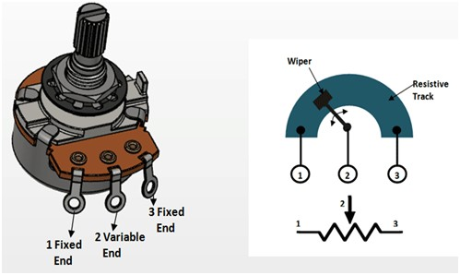

H bridge(L298N)

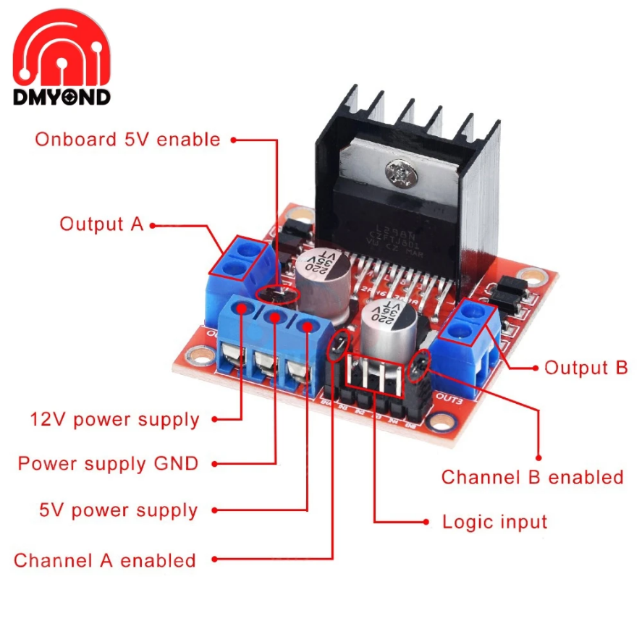

DC buck converter

# Appendix B Datasheet

Datasheet of 8051

https://datasheetspdf.com/pdf/556271/INTEL/8051/1

Datasheet of LCD

# Conclusion

The project is a microcontroller based hardware project which uses simple electronic components to provide security. It also aims to better our skills in handling such electronic components and our use of embedded systems. The project was assembled onto a box by fixing the LCD and keypad on the front, H bridge and breadboard on the top with BJT and external power supply connected to it and GSM module on the side.